

Rising Waters: A Machine Learning Approach to Flood Prediction

Project Initialization and Planning Phase

Define Problem Statements (Customer Problem Statement Template):
Create a problem statement to understand your customer's point of view. The Customer Problem Statement template helps you focus on what matters to create experiences people will love. A well-articulated customer problem statement allows you and your team to find the ideal solution for your customers' challenges. Throughout the process, you’ll also be able to empathize with your customers, which helps you better understand how they perceive your product or service.

Example:
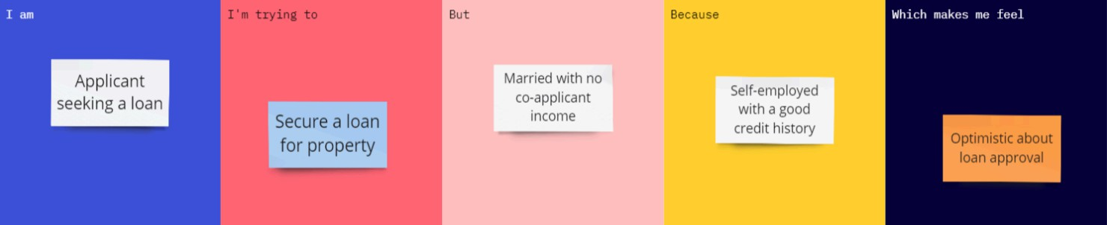

Problem Statement (PS) | I am (Customer) | I’m trying to | But | Because | Which makes me feel
PS-1 | A disaster management officer responsible for flood response and public safety. | Predict flood occurrences early and provide warnings to affected areas. | Flood predictions are not always available at the right time. | Existing forecasting methods may lack accuracy and require complex analysis. | Concerned about delayed evacuation, resource management problems, and loss of lives.
PS-2 | A meteorologist monitoring weather conditions in flood-prone regions. | Analyze rainfall and weather data to identify possible flood risks. | It is difficult to manually analyze large amounts of weather data. | Weather patterns are complex and require machine learning techniques for accurate prediction. | The need for an automated and reliable flood prediction system.
PS-3 | A person living in a flood-prone area. | Receive early flood warnings to protect family and property. | Flood alerts may not reach people with enough preparation time. | Current warning systems may not provide accurate and location-based. | Unsafe and uncertain during heavy rainfall and flood situations.

